Audit Report for **StandardToken**

Date: 12 August 2024

Audit result: **Passed**

**Token Address:** 0x61e689dBB8b85e4804197c6c461E6F0a7c22a953

**Name:** Apex Digital Exchange (PH)

**Symbol:** ADEXph

**Decimals**: 2

**Network:** Ether Scan

**Token Type**: ERC-20

**Owner**: 0xa3dc8e535440b33E08463e2fC7E98124cEe30e82

**Deployer:** 0xa3dc8e535440b33E08463e2fC7E98124cEe30e82

**Token Supply:** 5000000

**Checksum:** 1bba9d4a15920866c88fa711f22fe0de

**Testnet:**

<https://testnet.bscscan.com/address/0x1bc8b8432e72738f51f898e847b425d108c77fae#code>

**Token Overview:**

**Buy Fee:** 0-0%

**Sell Fee:** 0-0%

**Transfer Fee:** 0-0%

**Fee Privilege:** No

**Ownership:** Owned

**Minting:** No

**Max Tx:** No  
**Blacklist:** No

**Inheritance Tree  
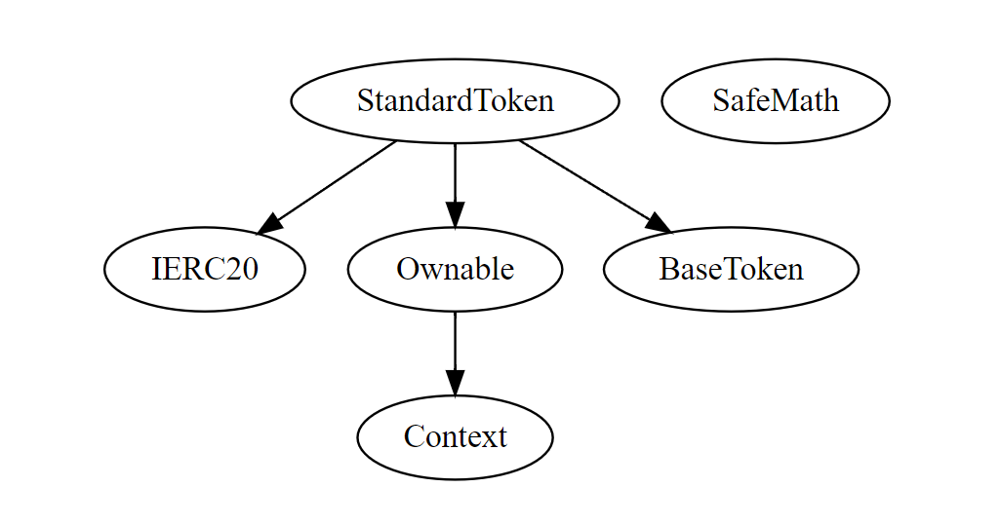**

**Static Analysis**

A static analysis of the code was performed using Slither. No issues were found.

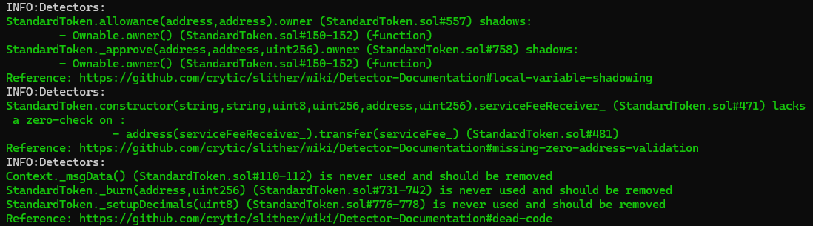

**Functional Tests**

**Router (PCS V2):**

**1- Approve (passed):**

<https://testnet.bscscan.com/tx/0xb61c0d40bdbcc629e979b259a3578a1d5c6e71c3bf0acc551911387757ffce91>

**2- Increase Allowance (passed):**

<https://testnet.bscscan.com/tx/0x98ff909de661b14755b87bbe03995e7661d8ef7ebcf1457b63f702807e8eaf04>

**3- Decrease Allowance (passed):**

<https://testnet.bscscan.com/tx/0x0769e38b4d41dd6b969f3b399289f75365eba8dd81cef0b76041dbfb9473630c>  
  
**4**- **Transfer (passed):**

<https://testnet.bscscan.com/tx/0x255fc4509d36fe5a971934dfa9dd5038e60f7109b60317572b732687379716dc>

**Ownership Privileges:**

- The owner can renounce ownership.

- The owner can transfer ownership.

**Findings:**

**Critical**: 0

**High**: 0

**Medium**: 0

**Low**: 2

**Informational** **&** **Optimizations**: 0

**Centralization – Missing Zero Address**

**Severity**: **Low**

**Status:** Open

**Overview:**

functions can take a zero address as a parameter (0x00000...). If a function parameter of address type is not properly validated by checking for zero addresses, there could be serious consequences for the contract's functionality.

**constructor**(

        string memory name_,

        string memory symbol_,

        uint8 decimals_,

        uint256 totalSupply_,

        address serviceFeeReceiver_,

        uint256 serviceFee_

    ) payable {

        _name **=** name_;

        _symbol **=** symbol_;

        _decimals **=** decimals_;

        _mint(owner(), totalSupply_);

**emit** TokenCreated(owner(), address(**this**), TokenType.standard, *VERSION*);

        payable(serviceFeeReceiver_).transfer(serviceFee_);

    }

**Suggestion:**

It is suggested that the address should not be zero or dead.

**Centralization – Remove the safe math library.**

**Severity**: **Low**

**Status:** Open

**Line Number: 205-416**

**Overview:**

The Safe Math library is no longer needed for Solidity version 0.8 and above. This is because Solidity 0.8 includes checked arithmetic operations by default. All of Safe Math’s methods are now inherited into Solidity programming.